Regulations of the project "Zamek’s Neighborhood Programme".
Organizer: ZAMEK Culture Center in Poznań.

- Definitions.
Organiser – Centrum Kultury Zamek with registered office in Poznań, 61-809, Św Marcin 80/82, registered under number RIK-II in the Register of Cultural Institutions kept by the President of the City of Poznań, holding NIP 7781019907 and REGON 000278178, hereinafter referred to as CK Zamek.

Public Programmes Department/PPD – a department of ZAMEK Culture Center responsible for the development and implementing the “Zamek’s Neighbourhood Programme”. The Department's office is located in the Organizer's headquarters in room 130. The coordinator of the “Zamek’s Neighbourhood Programme” is Adrianna Sołtysiak. Contact: in person at the PPD office and by email: a.soltysiak@ckzamek.pl

Zamek’s Neighbourhood Programme/Programme – a project aimed at supporting grassroots local initiatives in Poznan selected through the recruitment process and implemented with the support of the Programme coordinator. Programme includes the process of selection, implementation and financial settlement and evaluation.

Area of initiatives’s implementation – the Stare Miasto district (osiedle).
- The borders of the district (osiedle) are:
- from the west, the string of railroad lines No. 3 and No. 351, K. Pułaskiego Street;
- from the north, Armii Poznań Street;
- from the east, the Warta River (from the intersection of Szelągowska, Armii Poznań and Garbary streets up to Królowej Jadwigi Bridge);
- From the south, Królowej Jadwigi Street, Towarowa Street and Dworcowy Bridge.
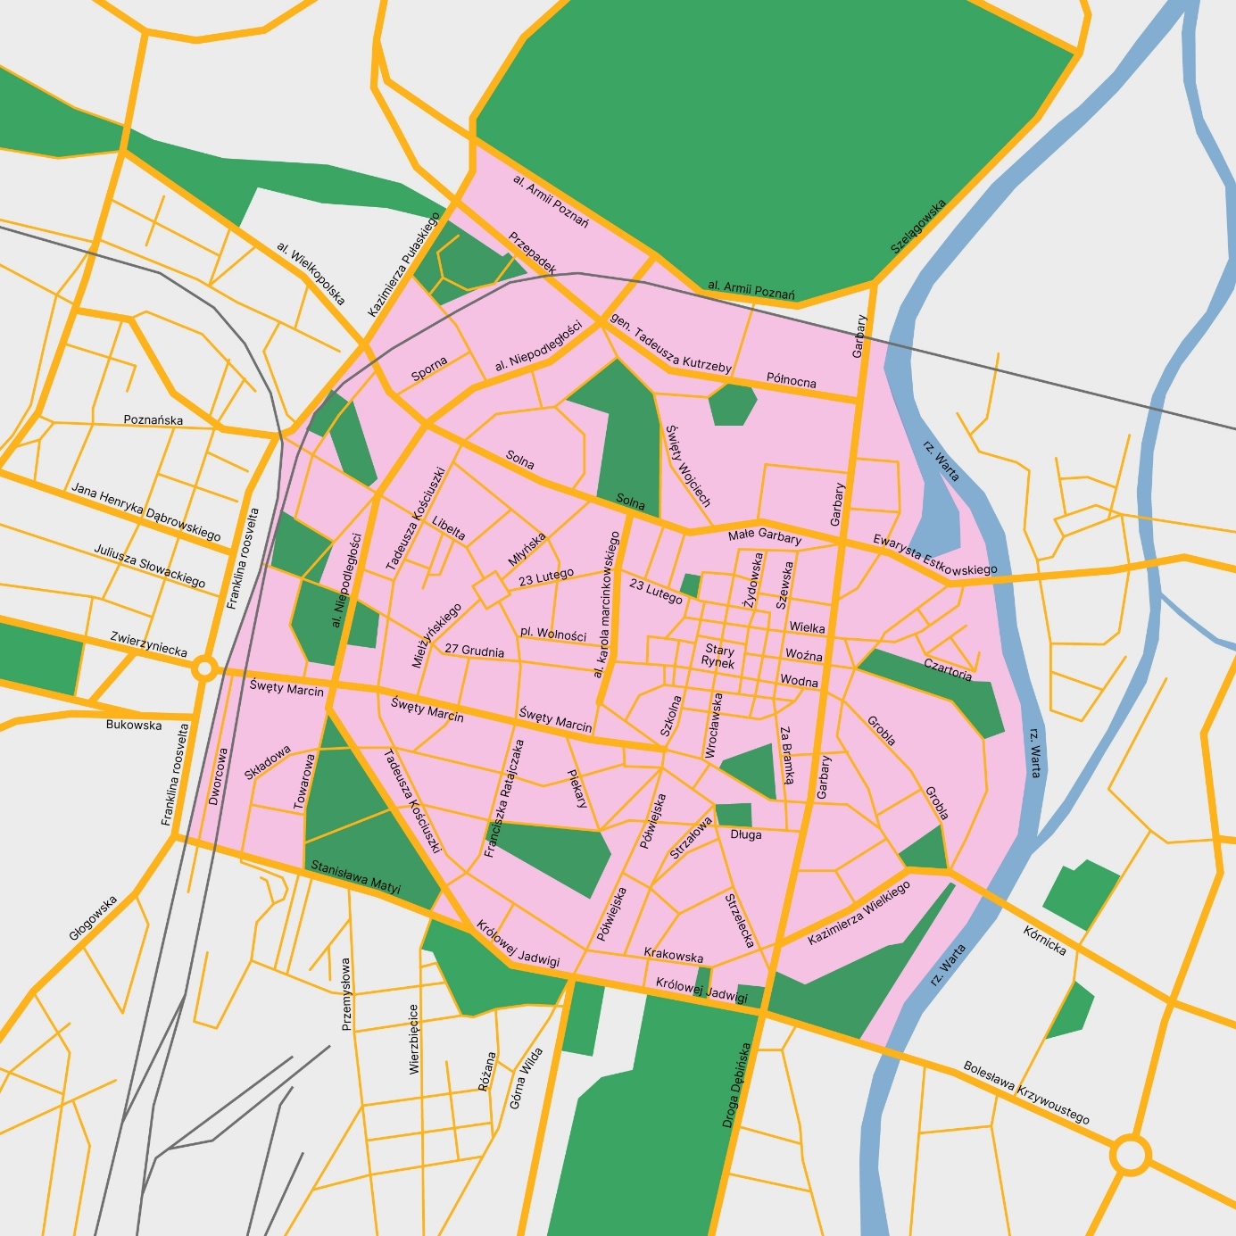

Participant – individuals, informal groups and non-governmental organizations (NGOs) who submit their application to the Zamek’s Neighbourhood Programme and are selected to implement their Neighbourhood initiative.

Application form – a formal application for a cultural, social, artistic, community engagement or educational initiative, submitted via the online form available at www.ckzamek.pl during the recruitment period, on the basis of which the Committee will select the initiative to be implemented in the Programme.

Recruitment – the process covering the period from the submission of application forms, through their selection by the Commission, to the announcement of the list of initiatives selected for implementation.

Commission – a group formed to substantively evaluate the submitted applications, made of the Organiser’s employees.

Neighbourhood initiative – a cultural, social, artistic or educational activity described in the application form, to be carried out as part of the “Zamek’s Neighbourhood Programme”.

- General Information.
- The Regulations of the “Zamek’s Neighbourhood Programme”, hereinafter referred to as the “Regulations”, set forth the general rules for the organization and conduct of the aforementioned event, hereinafter referred to as the “Zamek’s Neighbourhood Programme”.

- These Regulations are an integral part of the application for participation in the “Zamek’s Neighbourhood Programme”. Detailed information about the „Zamek’s Neighbourhood Programme” is available on the website: www.ckzamek.pl

- The organiser of the “Zamek’s Neighbourhood Programme”’ is Centrum Kultury Zamek in Poznań (61-809) with its seat at ul. Św. Marcin 80/82, referred to in the Regulations as the ‘Organiser’. Any questions, issues connected with the organisation of the “Zamek’s Neighbourhood Programme should be addressed to Adrianna Sołtysiak by e-mail a.soltysiak@ckzamek.pl or by phone +48 513 362 751.

“Zamek’s Neighbourhood Programme” is an activity focused on the implementation of neighbourhood initiatives within the Stare Miasto district (osiedle) or at the Organiser's premises. Its aim is to support the residents of Poznań in carrying out neighbourhood initiatives of a cultural, social, artistic or educational nature, based on diversity, equality, and the activation and integration of the local community.

- Orderliness of the „Zamek’s Neighbourhood Programme”" organization:
  - Participation in the open call for initiatives/ideas in the field of social activation and integration for individuals, informal groups and NGOs from Poznań takes place using the application form available at www.ckzamek.pl until 14.06.2026 at 23:59.
  - During the application period, face-to-face consultations with the Programme Coordinator will be held in room 130: on Wednesdays from 8.00 am to 11.00 am and on Thursdays from 5.00 pm to 8.00 pm.
  - The final selection of initiatives/ideas will be made by the Commission until 17.06.2026.
  - Individuals/groups/NGOs whose initiatives will be selected for implementation are required to attend an organizational meeting at the Organizer's headquarters on 23.06.2026.
  - The details of the neighbourhood initiatives (including the timetable, budget and promotional activities) will be finalised in close collaboration with the Programme Coordinator, Adrianna Sołtysiak.

- Priority will be given to such neighbourhood initiatives that:
  - are premised on the creating of common spaces that integrate different local communities;
  - break down stereotypes, build intercultural dialogue, and sensitize to linguistic and cultural diversity;
  - increase the awareness, knowledge and competence of those who participate, and therefore their self-agency in the world of social relations;
  - support and strengthen attitudes of openness, critical thinking and cultural participation;
  - facilitate communication and cooperation with different communities;
  - assume inclusion and access for people with various disabilities;
  - draw attention to climate issues and express efforts to reduce the negative impact of overproduction in the surrounding area.

- Participants.
- A participant in the “Zamek’s Neighbourhood Programme” can become a person who is 18 years of age or older, regardless of education background, nationality and place of residency.

- “Zamek’s Neighbourhood Programme” is addressed to individuals, informal groups and non-governmental organisations wishing to carry out their own neighbourhood initiative.

- Rules for recruitment.
- To participate in the recruitment for the “Zamek’s Neighbourhood Programme”, the application form must be sent electronically by June 14, 2026 at 11:59 p.m. The electronic application form is available at www.ckzamek.pl. The application form can also be sent in the form of an email to a.soltysiak@ckzamek.pl by the above deadline, with the completed form as an attachment to the email.

- Information on the processing of personal data can be found at www.ckzamek.pl.

- By 17.06.2026, the Organiser will inform by email about the selection of neighbourhood initiatives nominated for implementation as a result of the committee's deliberations.

- A reserve list will be created containing a list of persons who fulfill the criteria but are not accepted to take part in the “Zamek’s Neighbourhood Programme”. In the case of resignation of persons from the basic list (no later than 19.06.2026), persons from the reserve list will be qualified for participation in turn, after their prior agreement.

- Participation in the “Zamek’s Neighbourhood Programme” application is equivalent to reading the content of these Regulations and accepting the terms and conditions contained herein.

- The Organiser has the right to extend the recruitment in there are not enough applicants.

- Terms of participation.
- Participation in “Zamek’s Neighbourhood Programme” is free of charge. “Zamek’s Neighbourhood Programme” is part of the Poznański Program Edukacji Kulturowej project and is funded by the City of Poznan.

- The initiatives (which will receive funding for the “Zamek’s Neighbourhood Programme”) selected do not have the status of final action – they must be implemented “in process” in close cooperation with Programme Coordinator: Adrianna Sołtysiak.
- Implementation of neighbourhood initiatives: June-September 2026.
- The evaluation of the initiatives will take place in October 2026, on a date to be set by the Organiser.

- Organiser's Rights and Responsibilities.
- The Organiser reserves the right to document the “Zamek’s Neighbourhood Programme” by using of video and audio recording devices for use in promotional materials of Programme.

- The Organiser provides funding for neighbourhood initiatives in the total amount of 20,000.00 (twenty thousand) PLN gross. The maximum amount of funding for one initiative is 5,000.00 (five thousand) PLN gross. This means obtaining remuneration for Participants and covering the costs of necessary materials and services to enable the implementation of the neighbourhood initiative in the field of social activation and integration. Eligibility of costs will be determined each time with the Organiser.

- The Organiser will draw up a separate agreement with the Participant for the implementation of the neighbourhood initiative (assuming also the remuneration for the work done in the Programme).

- If, in a particular case, the Organiser will not enter into a contract with the Participant, the Organiser will draw up an internal order. The Participant will be obliged to prepare a report on the completed initiative. The report should include information about the progress of the initiative, the date the initiative was organised, the number of participants, photographic documentation. The Organiser may ask for additional information in the report.

- The Organiser shall not be responsible for any random events beyond the Organiser's control arising during the “Zamek’s Neighbourhood Programme”.

- Rights and Obligations of Participants.
- Implementation of the “Zamek’s Neighbourhood Programme” will be determined by a separate agreement between the Organizer and the Participant or by internal order.

- A Participant may resign from the awarded funding until 19.06.2026 by sending an email resignation to a.soltysiak@ckzamek.pl. If a Participant successfully resigns from the allocated funding, those on the established reserve list will be notified of the opportunity to participate in “Zamek’s Neighbourhood Programme”.

- Initiatives will be implemented in close cooperation with employees of the Public Programmes Department.

- Those selected to implement the initiative in the Programme are required to attend an organisational meeting. The meeting will take place on 23.06.2026 at Organiser’s headquarters.

- Personal data
In terms to the applicability of Regulation (EU) 2016/679 of the European Parliament and of the Council of 27 April 2016 on the protection of natural persons with regard to the processing of personal data and on the free movement of such data and repealing Directive 95/46/EC (General Data Protection Regulation), hereinafter referred to as RODO, we hereby inform you:

- The controller of the personal data of Participants and those taking part in the recruitment is the Zamek Culture Centre with its registered office in Poznań, Św. Marcin 80/82 street, 61-809 Poznań.

- In relation to the processing of personal data, you can contact the Data Protection Officer appointed by the Controller at the email address: iod@ckzamek.pl or in writing to the Administrator's address.

- Personal data will be processed:
  - for the purpose of taking part in the recruitment for the “Zamek’s Neighbourhood Programme” – on the basis of the consent given, i.e. Article 6(1)(a) RODO,
  - in order to implement the agreement and take part in the “Zamek’s Neighbourhood Programme” – on the basis of the agreement concluded, i.e. Article 6(1)(b) RODO,
  - for the purpose of recording, photographing filming or otherwise recording the image and statements and excerpts thereof of the Participants of the “Zamek’s Neighbourhood Programme” for publication in online and written publications, information and promotional materials and on the Administrator's websites and social media – on the basis of consent, i.e. Article 6(1)(a) of the DPA,
  - d) in order to fulfil the Administrator's legal obligations, including tax, accounting obligations – on the basis of Article 6(1)(c) of the DPA.
  - e) in the case of the Administrator's legitimate interest of investigating, defending against claims, conducting correspondence – on the basis of Article 6(1)(f) RODO.

- Personal data will be processed by authorised employees and collaborators of the Administrator. Recipients of personal data will be entities cooperating with the Administrator in order to carry out the recruitment for the “Zamek’s Neighbourhood Programme”. Data may also be transferred to entities providing services to the Administrator, in particular services related to the provision of IT systems, IT support, hosting services. The image and statements of people participating in the “Zamek’s Neighbourhood Programme” may be used for publication in online and written information and promotional materials, as well as on the Administrator's website and social media.

- In most cases, personal data will not be transferred outside the European Economic Area or disclosed to international organisations. Personal data may be transferred to third countries in connection with the use of services provided by Google entities; however, in such cases, the transfer of data is governed by agreements and provisions that guarantee an adequate level of protection for personal data. The transfer of data is based on the use of standard contractual clauses approved by the European Commission or on a decision by the European Commission confirming that the EU–US Data Privacy Framework provides an adequate level of protection for personal data – to the extent that the data recipient has joined this mechanism and holds the relevant certification.

- The personal data of persons who take part in the recruitment for the “Zamek’s Neighbourhood Programme” and are not qualified will be deleted after the recruitment has been carried out, unless the person concerned has consented to its further processing in order to receive information about further recruitment or open events related to the “Zamek’s Neighbourhood Programme”.

- The personal data of persons who conclude a contract with the Administrator as part of the „Zamek’s Neighbourhood Programme” will be stored for the duration of the contract and thereafter for the period required by law and, in justified cases, for the period of limitation of claims.

- Persons whose personal data are processed have the right to:
  - the right of access to the content of their personal data,
  - the right to rectification, erasure, restriction of processing,
  - the right to object.

- A person who has given her/his consent to the processing of personal data may withdraw consent to the processing of such data at any time by making a declaration to the Administrator. The withdrawal of consent does not affect the lawfulness of processing carried out on the basis of consent before its withdrawal.

- The person whose personal data is processed has the right to make a complaint to the supervisory authority, i.e. the President of the Office for Personal Data Protection, to the address of the Office for Personal Data Protection, 2 Stawki Street, 00 - 193 Warszawa, in case the processing of the data is considered to violate the provisions on personal data protection.

- The provision of personal data is voluntary, but necessary in order to take part in the recruitment for the „Zamek’s Neighbourhood Programme” and subsequently to conclude a contract and take part in the „Zamek’s Neighbourhood Programme”. Without providing this data, participation in the recruitment or execution of the contract will not be possible. Consent for the use of the image is voluntary, however, it is necessary in order to take part in the Programme.

- Personal data will not be used for automated decision-making or profiling.

- Final provisions.
- Application for participation in the “Zamek’s Neighbourhood Programme” is equal to acceptance of these Regulations.

- The Organiser reserves the right to make changes to the Terms and Conditions, but these changes must not harm the rights granted to Participants. Amendments shall become effective from the date of their posting on the website www.ckzamek.pl.

- The regulations enter into force on the date of publication on www.ckzamek.pl.

